**Project Design Phase-II**

**Data Flow Diagram & User Stories**

|  |  |
| --- | --- |
| Date | 30 June 2025 |
| Team ID | LTVIP2025TMID35759 |
| Project Name | Transfer Learning-Based Classification Of Poultry Diseases For Enhanced Health Management |
| Maximum Marks | 4 Marks |

**Data Flow Diagrams:**

A Data Flow Diagram (DFD) is a traditional visual representation of the information flows within a system. A neat and clear DFD can depict the right amount of the system requirement graphically. It shows how data enters and leaves the system, what changes the information, and where data is stored.

**Example:** [**(Simplified)**](https://developer.ibm.com/patterns/visualize-unstructured-text/)

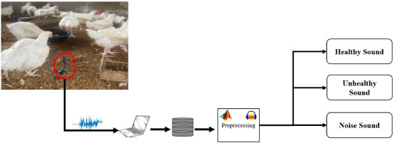

**Example:** DFD Level 0 (Industry Standard)

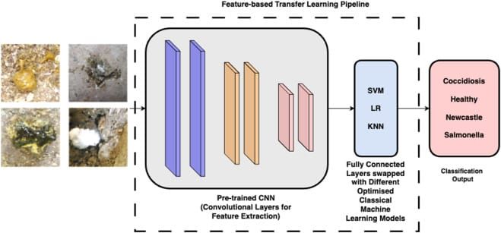

**User Stories**

Use the below template to list all the user stories for the product.

| **User Type** | **Functional Requirement (Epic)** | **User Story Number** | **User Story / Task** | **Acceptance criteria** | **Priority** | **Release** |
| --- | --- | --- | --- | --- | --- | --- |
| Poultry Farmer (App) | Registration | USN-1 | As a user, I can register using email and password | I can create an account and log in | High | Sprint-1 |
| Poultry Farmer | Upload Image | USN-2 | As a user, I can upload poultry images for disease detection | Image uploads successfully and is sent for  analysis | High | Sprint-1 |
| Poultry Farmer | Get Prediction | USN-3 | As a user, I receive the predicted disease name and possible treatments | Results shown with disease name and treatment  options | High | Sprint-2 |
| Admin | Manage Model | USN-4 | As an admin, I can update the ML model with new training data | Model is updated and retrained | Medium | Sprint-3 |
| Customer Support | Review Reports | USN-5 | As support, I can view past predictions and farmer details | Can access history of all users | High | Sprint-1 |